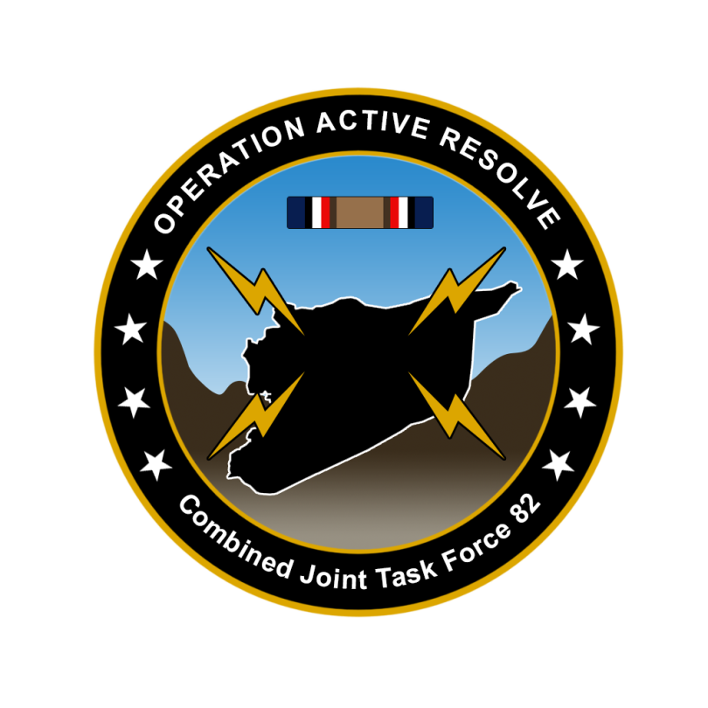

CJTF-82 DIRECTION AND GUIDANCE

D12

This document covers the friendly situation from D11 and provides CJTF-82 guidance to the entire force for D12.

**Reference CombatFlite**: <https://github.com/132nd-vWing/OPAR-Brief/raw/master/COMBATFLITE/OPAR%20Friendly%20situation.cf>

# SITUATION

## General situation

September 1st 2011 (D1) JFACC initiated airstrikes against Syrian forces while LCC started preparing its offensive. During D2 JFACC have continued engagements toward Syrian forces in Syria and in the occupied territory. Turkish local forces have been heavily engaged against Syrian forces IVO the Ataturk Dam, and despite support by CAS assets the area have fallen to Syrian hands. During D3 Syrian air assets have been reduced with efforts on Tabqa airbase. During D4 Syrian air assets was reduced through an attack at Hama airfield. JFACC supported LCC with several sorties to prepare for ground assault planned to start D5. During D5, JFACC focused on the effort of shaping the battlefield for LCC to set conditions for the ground assault that started on D6. During D6, ground forces were able to seize Gazintiep and have now taken control of the airfield.

On D6 the Turkish 33rd Brigade reported heavy fighting in along the FLOT SOUTH of Sanliurfa.

D7 saw continued fighting and further success by LCC increasing the area around Gazintiep. JFACC executed a unsuccessful strike towards SCC East at Tabqa.

During D8, LCC met hard resistance to on its way to crossing the Euphrates. At D8 JFACC successfully targeted SCC East at Tabqa and conducted a strike at The Syrian Air Defense Academy.

During D9 LCC successfully crossed the Euphrates and established control on the eastern side of the river, setting conditions to further push towards Sanliurfa. JFACC conduced strikes toward Raqqa vehicle factory, Palmyra and Hama airbases, and several SEAD/DEAD efforts supporting other operations, including in the vicinity of Kharab Ishk and Tal Siman.

During D10 LCC held its forces in static positions to rearm and refuel for a further push. JFACC supported LCC with AR both East and South of Gazientiep and set conditions for LCC further push in both directions. JFACC also continued strikes against factories ivo Raqqa and along the coast. DEAD was conducted on several targes ivo Tabqa, Kharab Ish, Tal Siman and IVO Tartus on the coast.

During D11 LCC continued offensive toward pushing the Syrians out of Turkey. With the support of JFACC they were able to get more ground. JFACC and MCC shaped and striked targets ivo the E-W lisne Shayrat-Tiyas-Palmyra, including strike the airfield at Palmyra and shaping for strikes at Shayrat. JFACC and MCC also conducted strikes at Tabqa and factories in Raqqa and Tartus.

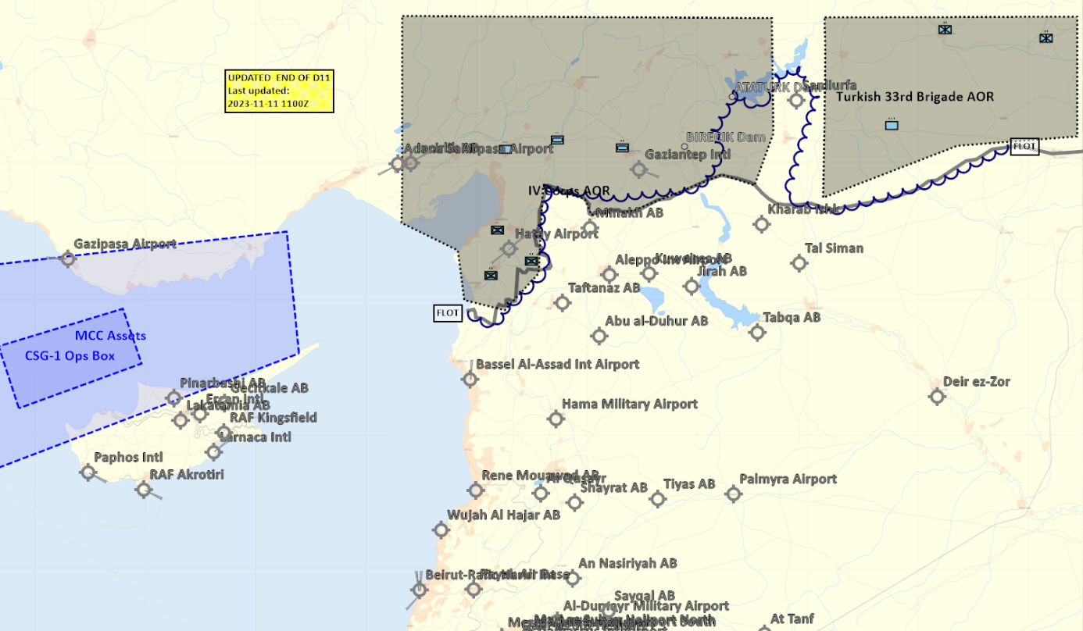

## Friendly situation

### Land Component Command (LCC)

#### IV Corps

55th Mechanized Division has secured HATAY and have moved forward battalions to screening positions along the FLOT.

56th Armor Division has its forward elements at the southern outskirt of Gaziantep and are moving according to LCC plan. Gaziantep Airfield is now fully under allied control and shipments of fuel and ordnance have started to arrive. The airfield can now be used for AH-64s and A-10s.

Local FLOT in Gazientep area:

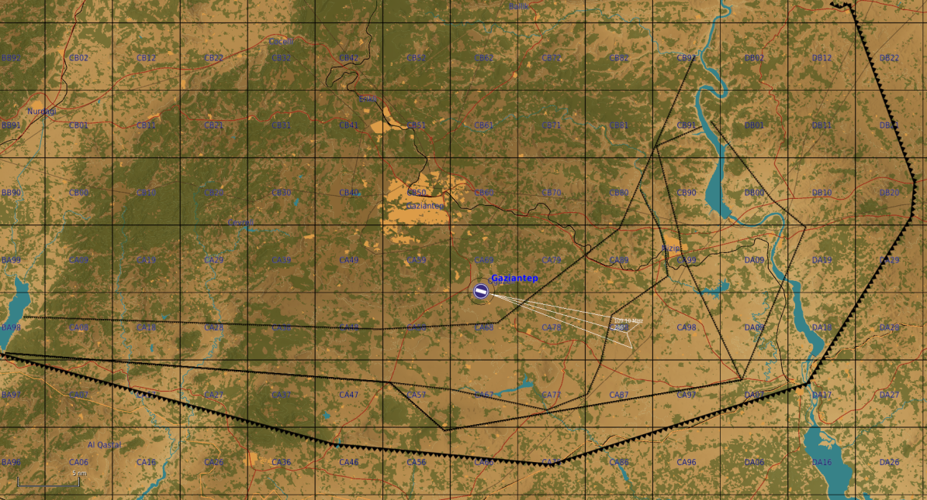

#### Turkish local forces

* The Turkish 33rd Brigade has been neutralized as an offensive force, but units are in defensive positions EAST of Sanliurfa in the 33rd brigade AOR.

### Maritime Component Command (MCC)

* CSG-1 continues to support the mission from CSG-1 operations box.
  + CVN-72 + Cruiser+ USNS Pauxent (Supply ship for MCC)
* MCC assets have left port ivo Incirlik area (MCC assets)
  + DDG x2
  + FFGH x1
  + SSN x1
  + USS Blue Ridge ( MCC Flag ship)
* Amphibious Ready Group / Marine Expeditionary Unit (ARG/MEU) in harbor, Crete
  + LPDx1
  + LSD x1
  + LHA x1
  + MV Tilde x1 (Supply ship)

### Joint Force Air Component Command (JFACC)

* IAW JFACC JAOP.

### Special Operations Component Command (SOCC)

* SOF teams are standing by to support with reconnaissance as required and requested by JFACC/VIS.
  + SOF team inserted to observe and report at: 922nd SCUD regiment Base (SYTGT003)
  + SOF team inserted to observe and report at: South Aleppo Rocket Fuel factory (SYTGT137)
  + SOF team inserted to observe and report at: Tartus (SYTGT056)
* SOF teams are also on standby to conduct counter terrorism missions and counter insurgency operations.

# Reported Battle Damage Assessment D8

## IV Corps Northern Sector

* NSTR

## Turkish ground forces.

* NSTR

# Logistical situation

* USS Sacramento (AOE-1) arrived in port on the morning hours of D12 and resupplied the ordanance of both the carrier and airbases.
* Ordnance request for D20 and onward need to be submitted by D15.

# Direction and Guidance

## LCC:

* Continue operation to free Gazientiep and free rest of Turkey
* Priority of effort is on 56th Armored Division attack at Gazientep.
* Coordinate with MCC if needing support of Marine Corps Expeditionary Unit (MEU)

## MCC:

* Plan for naval units as required[1]
  + Protect and operate Carrier
    - Support JFACC with minimum 8 sorties per ATO day
      * Minimum 4 sorties / 2x 2ship flights per event)
  + Monitor Russian and Chinese activity in the Mediterranean
* Activate and Deploy ARG/MEU as required
  + Currently in harbor in Crete. When activated, will be available after one ATO day. Will then arrive in RV point N35 12.000 E029 46.000
  + Coordinate with LCC for the use of embarked Marine Corps units (Marine Expeditionary Unit, MEU)
    - 3x companies of AAV-7
    - 2x companies of LAV-25
    - 1x company of Abrahams tanks
    - 1x Battery of 109mm Artillery
    - AH-64 (1x AH-64 can takeoff from LPD/LSD, up to 6x AH-64 from the LHA)[2]
    - AV-8B (Only if externals available)
* Request required ordnance for D12-20
* Plan for when the supply ship need to be in port and when the carrier need to refuel[3]

## JFACC:

* Apportionment[4]
  + DCA: Per JFACC priorities
  + OCA: Minium 50% of sorties should go to OCA (includes Airbase strikes, factories, SEAD/DEAD, etc)
  + Strike/Air Interdiction: Per JFACC priorities
  + Support LCC: 20%
    - AR: If no JTAC available, support to LCC can be given as AR
    - CAS: Priority of support to LCC should be given as CAS
* Priority of effort is on establishing Air Superiority in support of LCC and set conditions for own operations.
* Start shaping for phase 2 in the operation (Create permissive environment).
* Start strike operations in Syria as applicable.
* Continue support to LCC in effort to free Turkey.
* Be prepared to execute contingency plans for striking Syrian WMD at short notice (regardless of phase).
  + ALR: EXTREME approved for such a plan.
* Phase 2 planning:
  + JFC are working with political leaders to get an agreement to use airbases in Iraq during parts of phase 2. Airbases in question are H3, H3 Northwest. H3 Southwest. JFACC can at some point start contingency planning for using these airbases (Need ATC charts, coordinate with 176th), how can the airbases be used to best support JFACC (what squadrons to be based there?), what targets, or what can be achieved by using these bases.
  + A parallel effort to using the airbases in Iraq is to ensure overflight rights over Lebanon or Israel for any carrier based aircraft.
  + We do not have a time estimate, but it will not happen until Phase 2 at the earliest.
  + Submit CONOP (Concept of Operations) for phase 2 to CJTF HQ for approval
  + CONOP submitted ASAP to JFC (coordinated with LCC).

## VIS:

* Support JFACC, LCC and MCC planning and execution.
* Be prepared to support JFACC with creating contingency plan for striking Syrian WMD at short notice.
* Recommend to JFC changes in diplomatic status for any country

## Diplomatic situation

* Syria is declared as enemy
* Russia is declared as adversary (Discussion and possibility for change during tgt meeting D12)
* Jordan is declared as neutral
* Lebanon is declared as adversary (changed from NEUTRAL on D9)
* Turkey is declared as friendly
* Israel is declared as neutral
* China is declared as adversary (Discussion and possibility for change during tgt meeting D12)
* Iran is declared as adversary
* Iraq is declared as neutral
* Libya declared as adversary

Only units declared as enemy can and should be engaged by CJTF forces.

**Definitions:**

Enemy: is actively opposed or hostile to CJTF and friendly forces.

Adversary: opponent in a contest, conflict, or dispute toward CJTF and friendly forces.

Neutral: not supporting or helping either side in a conflict, disagreement, etc.; impartial.

1. Create SAG or CSGs as required, and task the ships (by providing info to event host)
2. Coordinate with 656th if they are able to do naval operations from ships. Coordinate with JFACC for use of 656th assets
3. The carrier need to get fuel for the jets every 7 days. The supply ship need to be in port in two days to get supplies and fuel). If using missiles, the other supply ships can pick up missiles at port and bring them out to the ships
4. Air apportionment is the determination and assignment of the total expected effort by percentage and/or priority that should be devoted to the various air operations and/or geographic areas for a given period of time.